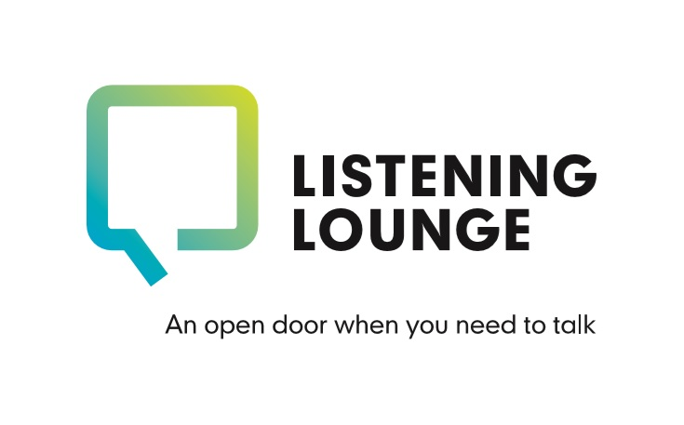

Counselling Initial Evaluation Form

You’ve received this form as your counsellor would like you to revisit the set of questions you were asked to consider prior to your initial assessment. This helps both yourself and us gauge how counselling is helping you or highlight any changes in how you’re feeling. We ask you to do this midway through counselling, usually at session 3, and again at the end, usually at session 6. Please complete the form below by clicking in the relevant boxes and marking with ‘X’ or the appropriate number. You can then save your completed form and return by email to your counsellor directly.
Alternatively, you can return this form by post by printing and completing by hand. Return to the following address: Counselling Team, The Listening Lounge, Charles House, Charles Street, St Helier, JE24SF. Should you need any support to complete this please do call us: 01534 866793.

Your name: ………………………………………………….. Today’s date: ……………………………………………..
Midway review |  | End of sessions review

Please mark as appropriate:

Over the last 2 weeks, how often have you been bothered by the following problems? | Not at all  0 | Several days  1 | Over half the days  2 | Nearly every day  3
Feeling nervous, anxious or on edge
Not being able to stop or control worrying
Worrying too much about different things
Trouble relaxing
Being so restless that it’s hard to sit still
Becoming easily annoyed or irritable
Feeling afraid as if something awful might happen
For office use
 | Not difficult at all | Somewhat difficult | Very difficult | Extremely difficult
If you checked off any problems, how difficult have these made it for you to do your work, take care of things at home, or get along with other people?

People’s problems sometimes affect their ability to do certain day-to-day tasks in their lives. Please consider each section below and determine on the scale provided how much each problem impairs your ability to carry out the activity. If you are retired or are not currently employed due to reasons unrelated to your mental health & wellbeing please tick here:

0  Not at all | 1 | 2  Slightly | 3 | 4  Definitely | 5 | 6  Markedly | 7 | 8  Very severely

Because of my mental health my ability to work is impaired (0 = not at all and 8 = unable to work)
Because of my mental health my home management is impaired (cooking, cleaning, shopping, childcare)
Because of my mental health my social leisure activities with other people are impaired (outings, bars, etc)
Because of my mental health my private leisure activities are impaired (done alone, e.g reading, TV, music)
Because of my mental health my ability to form and maintain close relationships with others is impaired

Over the last 2 weeks, how often have you been bothered by the following problems? | Not at all  0 | Several days  1 | Over half the days  2 | Nearly every day  3
Little interest or pleasure in doing things
Feeling down, depressed, or hopeless
Trouble falling or staying asleep, or sleeping too much
Feeling tired or having little energy
Poor appetite or overeating
Feeling bas about yourself – or that you are a failure or have let yourself or your family down
Trouble concentrating on things, such as reading the newspaper or watching television
Moving or speaking so slowly that other people have noticed, or being so fidgety that you are moving round a lot more than usual
Thoughts that you would be better off dead or of hurting yourself in some way
For office use

 | Not difficult at all | Somewhat difficult | Very difficult | Extremely difficult
If you checked off any problems, how difficult have these made it for you to do your work, take care of things at home, or get along with other people?

We treat issues relating to consent and confidentiality with the upmost of importance. The information you provide to us is stored securely and accessed only by those in the team who require it. Anonymised data may be shared with the Government of Jersey as part of our agreement as a service provider. Following your initial assessment, if we’re able to support you with counselling we will inform your GP as part of our standard process. We will not discuss any information about you outside of the Listening Lounge without your prior agreement, except in exceptional circumstances. For example, we would have a duty to pass on information if we were concerned that there was a serious risk of harm to yourself or others.

By returning this form to you us you are both acknowledging and agreeing to the above statement.

