Office use
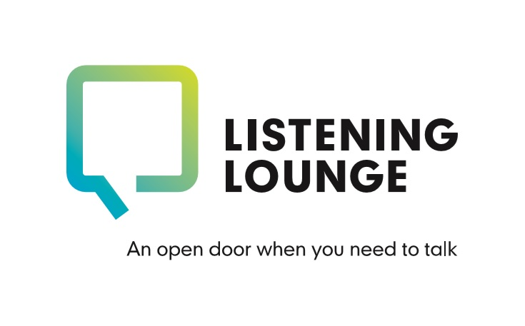

Counselling Self-Referral Form

If you’d like to register for counselling with us, please complete the form below by clicking in the relevant boxes and typing your response. Please save your completed form and return to us by email: counselling@listeninglounge.care
This is a secure email address accessed only by our counselling team. Please include your name in the subject on your email. Alternatively, you can return this form by post by printing and completing by hand. Return to the following address: Counselling Team, The Listening Lounge, Charles House, Charles Street, St Helier, JE24SF.
Should you require any support to complete and return this form please do call us so we can assist you: 01534 866793.

Full name: | Today’s date:
Date of birth: | Email address:
Contact number:  Is it okay to leave a voice message?  Is it okay to send a text? | Address:  Is it okay to write to you?
What is your preferred method of contact? | Name and phone number of emergency contact:
GP surgery and name of GP: | Details of any current prescribed medication:
Are you currently receiving input from any other service/s in relation to your mental health and wellbeing? If so, please provide details: | If you have answered yes, do you agree for us to contact them if required? We will always endeavour to discuss this with you first.
Due to current social distancing guidelines we are currently unable to meet with you face to face. Instead we are offering all appointments by phone or online using Zoom. Which is your preference? | If you are happy to, please briefly outline the difficulties you are experiencing:  (this will help us allocate the most appropriate person for your initial assessment but is not compulsory)

We treat issues relating to consent and confidentiality with the upmost of importance. The information you provide to us is stored securely and accessed only by those in the team who require it. Anonymised data may be shared with the Government of Jersey as part of our agreement as a service provider. Following your initial assessment, if we’re able to support you with counselling we will inform your GP as part of our standard process. We will not discuss any information about you outside of the Listening Lounge without your prior agreement, except in exceptional circumstances. For example, we would have a duty to pass on information if we were concerned that there was a serious risk of harm to yourself or others.

By returning this form to you us you are both acknowledging and agreeing to the above statement.
One of the team will contact you shortly to arrange a suitable time for your initial assessment with us.

