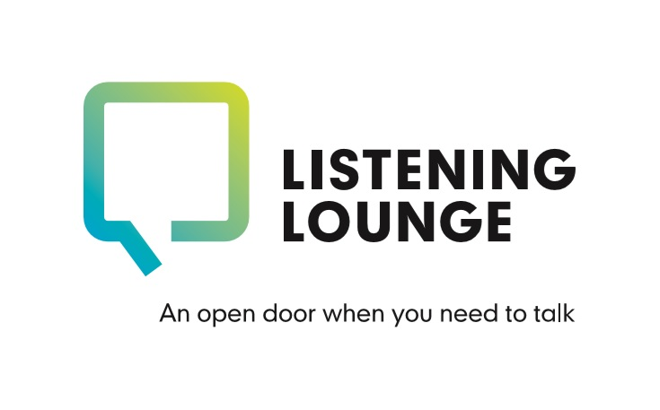

Counselling Agreement

This is a mutual agreement between the Counsellor and the Client, or Client’s Representative, prior to starting counselling at the Listening Lounge. It outlines the responsibilities of the Counsellor towards the Client, and the Client’s responsibilities in the counselling relationship.

This agreement is between ……………… , Counsellor, and ………………, Client or Client’s Representative (delete as appropriate).

Commencing on ……………......

The Counsellor;

The Listening Lounge is provided by LINC Mental Health & Wellbeing. All our counsellors at LINC adhere to the BACP (British Association of Counselling and Psychotherapy) code of ethics for Professional Counsellors. LINC also holds Organisational Membership with the BACP, our registration number being 275357. Some therapists may also be members of, and regulated by, additional bodies including the UKCP (United Kingdom Council for Psychotherapy) or National Counselling Society.

Confidentiality;

This is a very important aspect of the counselling relationship. Everything that is discussed with your Counsellor is confidential and accessed by appropriate Listening Lounge employees and Counsellor supervisors only. As standard we will inform your GP that you are receiving counselling at the Listening Lounge. If there are significant concerns that you intend to harm yourself or others your Counsellor may need to break confidentiality by informing your GP, or in serious cases the Police, emergency services, or other appropriate third party. Wherever possible and if it is considered appropriate, your Counsellor will endeavour to discuss this with you first. Your Counsellor will keep brief notes after a session, which will be stored securely.

Contact with us, mobile and email use;

The Listening Lounge can be contacted by calling 01534 866793 from 10am until 10pm. Out of hours there is an option to leave a message and we will return your call as soon as possible.

Alternatively, you can email us at info@listeninglounge.care

Sessions;

Each session lasts 50 minutes. You would usually meet your Counsellor once a week, at the same time and day each week, however this will dependent upon your own needs and preferences. If your circumstances change and your session time is no longer suitable please inform your Counsellor so we can look to accommodate an alternative date or time for you.

Cancellation and Holidays;

If you are unable to attend a session, please provide as much notice as you can. We appreciate from time to time this may not be possible and will always try and offer an alternative day or time to you. Equally, Counsellors will give you as much notice as possible if they are unable to make a session due to holidays, training or sickness.

Duration of Counselling;
You will be offered up to 6 face to face sessions with your Counsellor following your initial assessment.

Face to Face contact outside sessions;
Should you happen to meet your Counsellor outside of your sessions please be aware that they will not greet you. This is to protect your privacy and maintain confidentiality. This is especially important if you are with other people. If you acknowledge them openly however, they will respond in an appropriate manner.

Facebook, Twitter and other social media;
Please do not invite your Counsellor to join you on any social media platforms. They are not permitted to do so under their Code of Ethics or our policies and procedures and refusal or unacceptance of such requests may cause offense when none is intended.

Monitoring your progress;
You will be invited to complete one or more short assessment tools before your first session with your Counsellor. These may be called the Core 34, GAD-7 or PHQ-9. Usually, these assessments are revisited part way through and at the end of your therapy. It is not compulsory that you complete these however the purpose is to help monitor your progress and so that both you and your Counsellor can identify if therapy is helping you.

Endings;
Your Counsellor will discuss this with you as you approach the end of your sessions. Your counsellor will not be able to work with you if you are under the influence of alcohol or mind-altering substances. If this were found to be the case your Counsellor will have to end the session. The Counsellor reserves the right to terminate therapy where the Client is perceived to be a threat to the Counsellor’s wellbeing. Abusive behaviour is unacceptable and will not be tolerated.

Online and phone counselling;
During times when face to face sessions are not possible, we will endeavour to offer phone and online sessions as an alternative. Session times and preferred method will be agreed with you in advance. We ask that you consider where you will be located for online and phone sessions to ensure that, as far as possible, you have a safe and uninterrupted space to use. If your Counsellor is unable to reach you online or by phone as agreed, they will attempt to reach you on a second occasion 10-15 minutes later and work with you for the remainder of your session. If your Counsellor is unable to reach you, and if we have not been contacted by yourself to let us know that you are experiencing technical difficulties, we will then assume that you will not be attending your session. Should there be ongoing or significant interruptions or technical difficulties during the session it may be necessary to rearrange this for another time. To ensure privacy and confidentiality is maintained, we ask that neither party record these sessions.
Please read this contract carefully before signing. Should you have any questions please let us know so we can discuss these with you. By signing below you acknowledge that you both understand and agree to the terms of this agreement:

Client, Client’s Representative, or Counsellor if recording verbal consent given online or by phone;
Name:
Relationship to client if acting as Client’s Representative (if applicable):
Counsellor (if applicable):
Signature:
Date:

Counsellor;
Name:
Signature:
Date:

