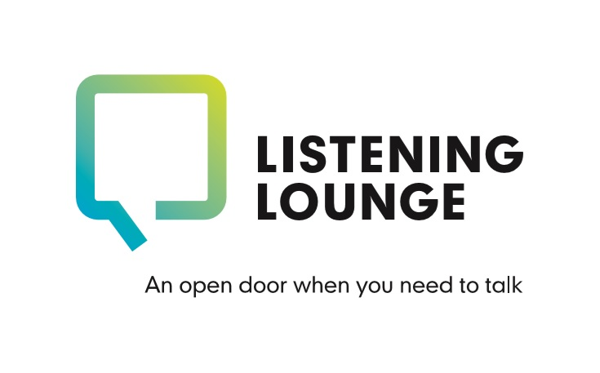

Client – Counsellor Feedback

This form allows you an opportunity to provide feedback to your counsellor after your sessions have finished. This will help your counsellor’s professional development as well as helping to improve the service offered to others. This form can be completed anonymously. Please place a mark in the box which most closely corresponds to how you feel about each statement.

Your counsellor’s name: _______________________

About the working relationship with your counsellor: | Strongly agree | Somewhat agree | No strong feeling | Somewhat disagree | Strongly disagree
My counsellor listened to me effectively
My counsellor understood things from my point of view
My counsellor focused on what was important to me
My counsellor accepted what I said without judging me
My counsellor showed warmth towards me
My counsellor fostered a safe and trusting environment
My counsellor began and finished our sessions on time
My counsellor challenged me when/if that was appropriate
My counsellor followed my lead during our sessions when appropriate
My counsellor provided leadership during our sessions when/if appropriate

About the results of working with your counsellor:
 | Strongly agree | Somewhat agree | No strong feeling | Somewhat disagree | Strongly disagree
The sessions with my counsellor helped me with whatever originally led me to seek counselling
Any changes which might have occurred in me as a result of my counselling have been positive and welcome.

Overall satisfaction:
 | Very satisfied | Somewhat satisfied | No strong feeling | Somewhat dissatisfied | Strongly dissatisfied
My overall level of satisfaction with the service provided by my counsellor is
Based on my experience, I would recommend my counsellor to others
Other comments:

Please use the space below for any other comments you would like to bring to your counsellor’s attention. (If there are any matters which you specifically would not have wanted to discuss with your counsellor in person, your counsellor would be especially glad to know of these). If you include your name in this section, it will be treated as confidential. If you need more space, please continue on the back.

